**22.3.1**

Wow. That’s some bad weather outside.

I know. It’s very windy

I very wet from the showers. This jacket is terrible. All of my cloth are wet.

I don’t like rain but I really don’t like snow.

I’m sorry , Ananaya. But snow is on the way. I saw the weather report. Temperature below freezing next week. Weird! Lock!

What’s wrong with the door?

I don’t know.

Try again

It’s see new idea.

Getting side.

Maybe we can go home because we can’t get it.

But we can get it, conduction right here.

Hold ID upright

Press ID against card reader for FIVE SECONDS

One, two, three, four , five . We can go now.

No we can’t

Look at this. It’s at Hold for TWO MORE seconds until it beeps two times.

It works.

Stupid, rain. Stupid windy day

When Marco fist tries to open the door, why doesn't it unlock?

-> It does unlock because he has a new ID

How does Aanya feel about rain and snow?

-> She doesn't like rain, and really doesn't like snow

How do they open the door?

-> They read the instructions

When Tood arrives, what is he angry about?

-> He is angry about the wind and the rain.

**Conversation**

Long time no see. How was the weather in NY?

Last summer wasn't hot, but this summer is verry hot

What were your favourite time of the year?

Spring, when is was warm, not hot and not cold.

So. It never rain in spring.

Oh, yeah. It's rain some time, but I have my umbrella

When weather really bad weather?

The winter was very bad. It was windy and the temperature bellow freezing

Is snow a lot?

Yes. There was lot of snow on the streets

How was NY in the fall?

Really beautiful. Not hot and not cold. It was a little windy. Great weather!

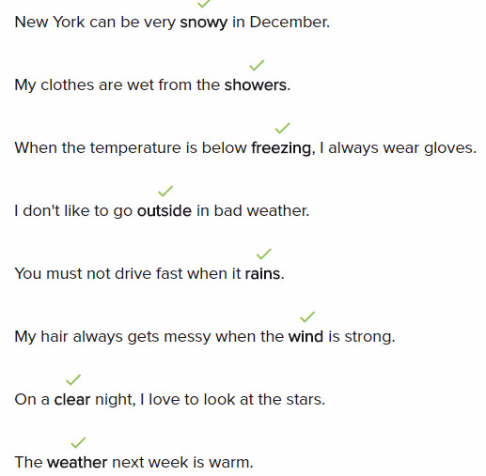

**Exercise**

A: When do your clothes get wet?

->When you don’t use an umbrella on a rainy day

The weather report says it’s below freezing tonight.

->That’s cold

You don’t see clouds when the sky is clear.

People need to wear coats in snowy weather.

What weather is bad to drive in?

->In rainy and freezing weather

The weather report says that there are showers tonight.

How can you learn about tomorrow's weather?

->You can look at the weather report.

What do people do outside when the weather is good?

->People can play or walk in the park.

22.3.2

Do you want to go out for lunch today?

No. It’s rainy outside. So we’re staying in

Yes please. **I can’t go into the rain because my jacket is terrible**

**And I can’t go into the rain because because my umbrella is broken**

OK. Why are you looking at your jacket?

**I’m product designer, my jacket is terrible so I want to design a new one.** Can you guy tell me with it? Maybe we can use that design idea for the Big Boss

**We have our idea, so we don’t need a second idea**

**We need a second idea because the first idea might not work**

She’s right. What’s your jacket idea?

I think we can design a jacket, that cheap, and everyone can use

Tell me more

It have to be light, keep your dry, and keep you cool on hot day or warm on cold day. Yes!

It looks like the old jacket

Wait a minute. **What do you think?**

I’m confused

Every part of the jacket is removable. It warns when you want to be warm. Cold want you want to be cold. You can change it. When I want to go on sunny, to rainy

**I think we can make it work!**

**I think your jacket is a winner**

Cool!

But we think to add the pocket, so we can put the pieces of the jacket inside

I think you’re right

**And. I don’t think that every piece need to be removable**

I think this is amazing idea of Khea

Thank you

I think this is my idea now

Why does Khae want to design a new jacket?

-> She doesn’t like her jacket

What kind of jacket do they want to design?

-> A cheap and useful jacket

What is Marco’s idea for the jacket?

-> To add a pocket

Why was Todd in the hallway?

-> He was there to take their idea

Practice

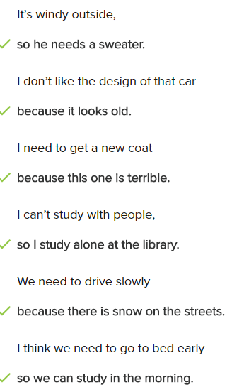

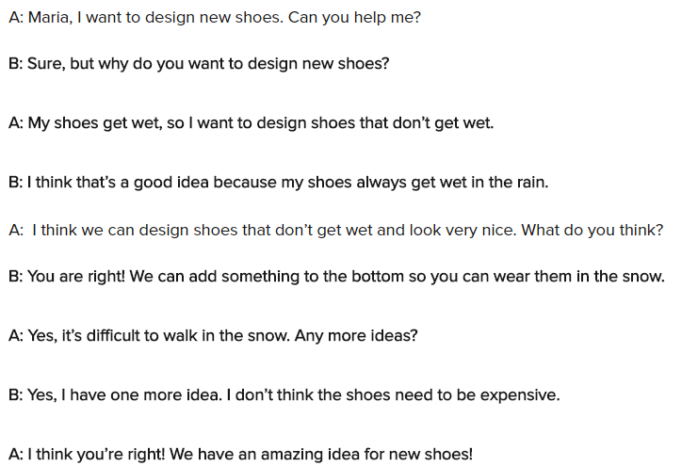

**Skills Practice**

I think you need a hat. It’s cold outside

-> I don’t need my hat. It’s snowing, but it’s not cold

What do you need when it rains?

-> I need a rain jacket and an umbrella

Why don’t you like this bicycle? It’s not expensive

-> Yes, it’s cheap, but I don’t like the design

I like this hat because it has a good design

-> Me too. I like the color and it keep my head warm

I don’t think we can go to the park it’s raining

I like this jacket design because it has pocket and it is easy to wear

I want to make a new toy for children

-> I thinks that’s a great idea because children love toys!

What are you drawing?

-> I don’t like my shoes, so I’m designing new ones!

I thinks we can design a new umbrella

**Conversation**

Hi Mitch. Do you want to work in class room?

Sorry? Can you repeat that please?

Do you want to work in class room?

There are too many people in the classroom, Let work in the cafe

OK, what do we need to design with?

Oh, I think we only need the pen and paper

OK, do you have idea about what product we can design?

I think we can try to design a new umbrella

What kind of umbrella?

I think we can design an umbrella that keeps us dry and warm

Woa, that’s a great idea. I think we need to add the pocket. What do you think?

Yes, I think the pocket is a good idea for wallet and cell phone

**Exercise**

Do you like your new computer?

-> Yes. I like my new computer because it is fast and easy to use

What did you think about the new movie?

-> I think it was very funny

What do you think about my idea?

-> I think this is an amazing idea!

Why don’t you go home?

-> My umbrella is broken, so I can’t go outside

Noah wants to buy a car that has a good design and that’s easy to drive

How do I drive when it snows?

-> I thinks you have to drive slowly

This restaurant is expensive, what do you think?

-> I think we can cook and eat at home

I think this product is terrible because it’s expensive and not useful

**Read for Meaning**

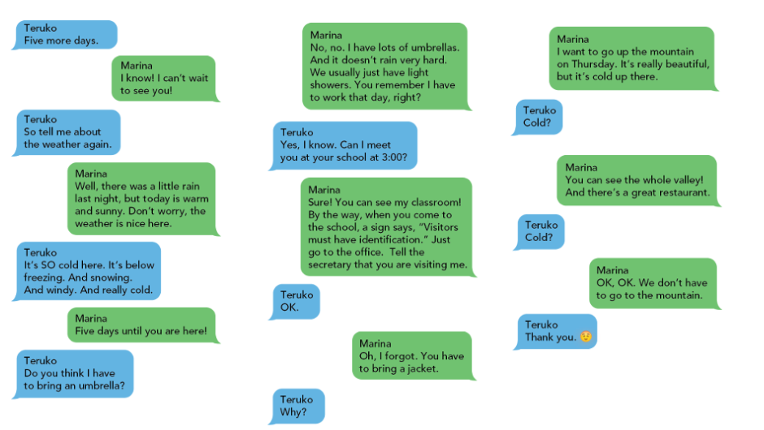

What are Teruko’s plans?

->To meet marina

How is the weather where Teruko is?

->It is very cold

When does Teruko arrive?

->In five days

Teruko does not need to bring an umbrella because **Marina has umbrellas**.

Where does Teruko decide to meet Marina?

-> At Marina’s school

Why does Teruko not want to go to the mountain?

-> She does not like the cold.

**Practice**

You **have to** turn off your cell phone.

You **must** turn off your cell phone in the library.

The tennis match is next week, so I **have to** play tennis every morning.

I want to be healthy, so I **must not** eat many cakes.

My mother **has to** wear glasses when she reads the newspaper.

Tomorrow is a holiday , so I **don’t have** to go to work.

I **must** remember to bring my homework to class tomorrow.

Why do you **have to** go home early?

Please take out your passport.

The restaurant is closed today.

Please turn off the computer.

You must not stop here.

No talking in the classroom.

**Skill Practice**

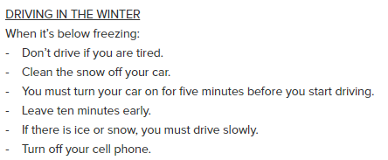

You need to clean snow off your car.=>True

Turn your car on for a few minutes before you start driving. .=>True

It is better to leave late. => False

It is better to drive slowly in the snow.=>True

It is okay to use your phone while you drive. => False.

**Exercise**

Sam: Do I need a jacket?

->Linda: No. It’s not windy, so you don’t have to wear a jacket.

Take your umbrella because there are **showers** tonight.

Mom: Why do you need a computer?

->Brian: I have to look for information for my science class.

What does this sign mean?

->No phones.

A: How’s the weather there?

->B: It’s great! It’s warm and sunny.

A: Why do I need this ID card?

->B: You must use your card to open the door.

What does this sign mean?

->You can go in.

There’s ice on the street. It’s below freezing.